# Screen a protein sequece against a MOTIF database

# Introduction

A mentioned in the theory starting from a multiple alignment a motif model can be built (PWM, profile, HMM). For premade, curated alignments these models are stored in motif databases (two of which will be discussed here, PFAM and Prosite).

If you have a new sequence, you can screen it against a motif database to assess which domains/motifs are present in the new protein. This is referred to as screening or scoring a sequence with a motif model or said otherwise aligning a sequence with a motif model. You can screen with a PSSM, a profile or a HMM. To screen with an HMM you need specialized algorithms (Viterbi algorithm) i.e. finding the best path that would generate you sequence given an HMM motif model (see theory part 2 and 3).

In this exercise we will perform such analysis.



In this exercise we will first annotate our newly sequenced protein by testing whether it contains previously annotated protein domains. We will do this by screening our protein against the diverse protein domain databases.

We start with the following query sequence. We want to screen this sequence to protein domain databases in order to detect whether it contains conserved domains or profiles.

>gi|1071819|pir||B54759 ba-type ubiquinol oxidase Paracoccus denitrificans



The query protein belongs to the same protein family for which we constructed a multiple alignment with Clustal omega in the previous course. So we expect that the regions conserved in this multiple alignment are the ones that are captured in the protein databases by profiles or domains and that these should be recovered in our query protein (this is a sanity check).

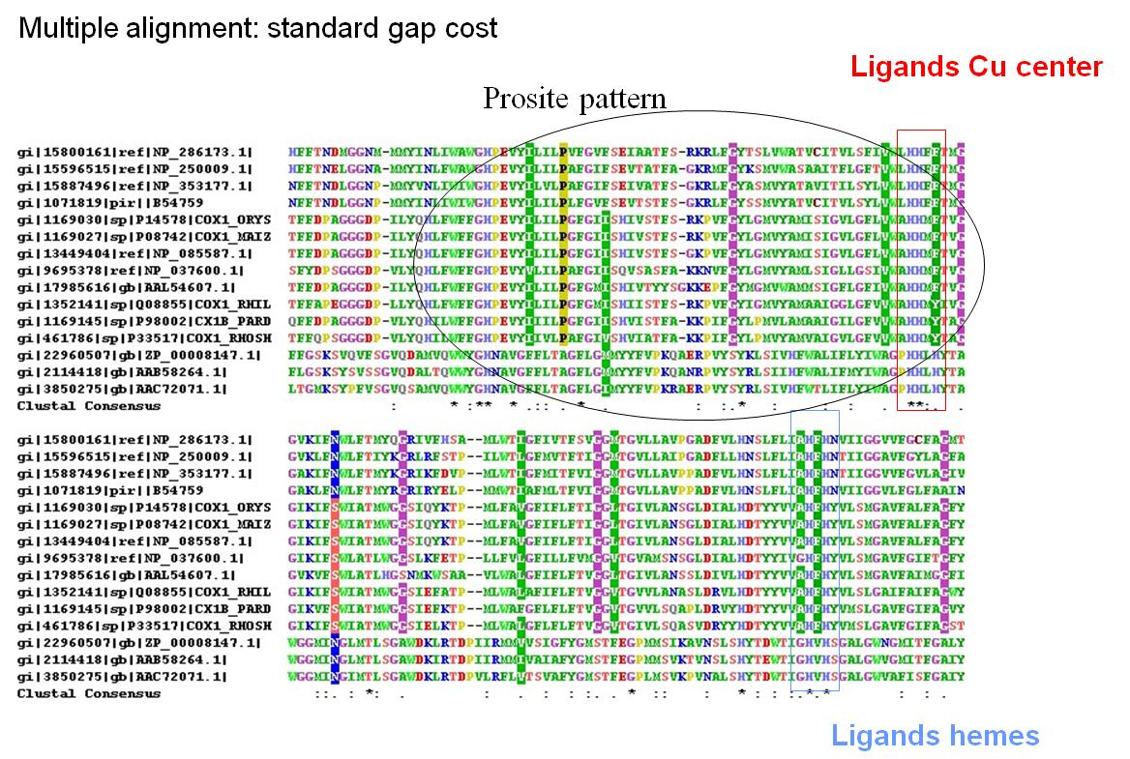

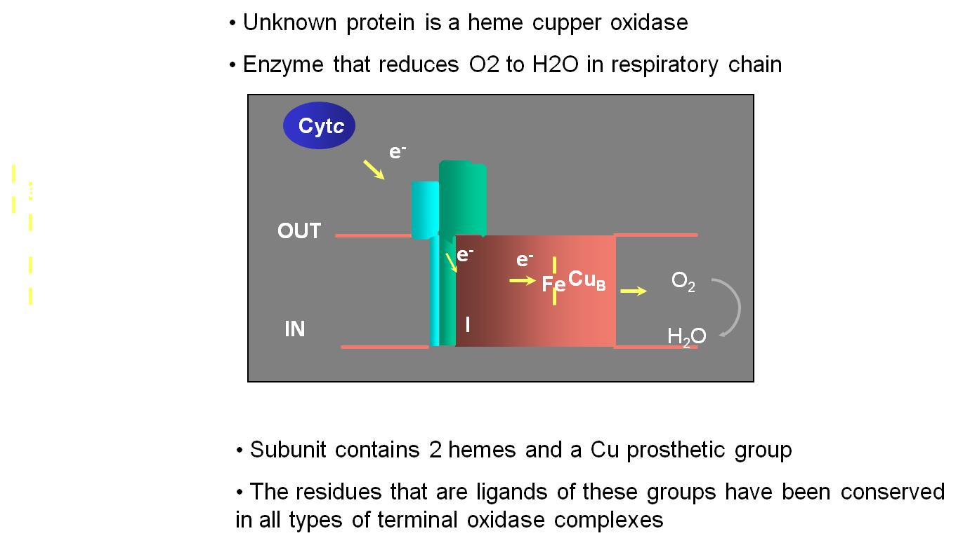

## Interpro

Note that the original PFam and Prosite have been integrated in Interpro. You will now have to start the search from interpro.

<https://www.ebi.ac.uk/interpro/search/sequence/>

Perform a search by sequence and use the advanced options to indicate the databases of interest you want to use (Pfam and Prosite). Nte that the results of your screening are saved.

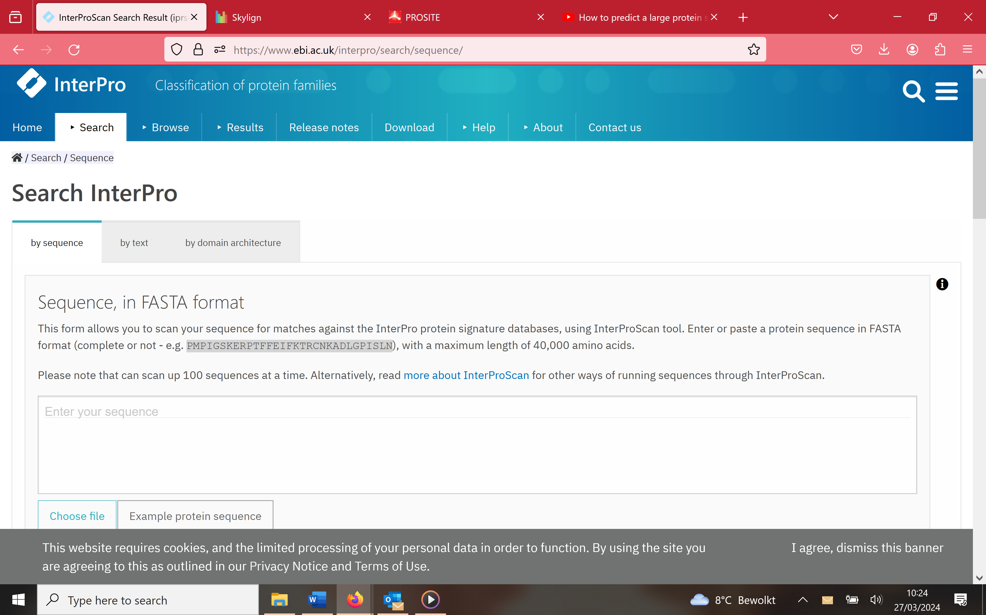

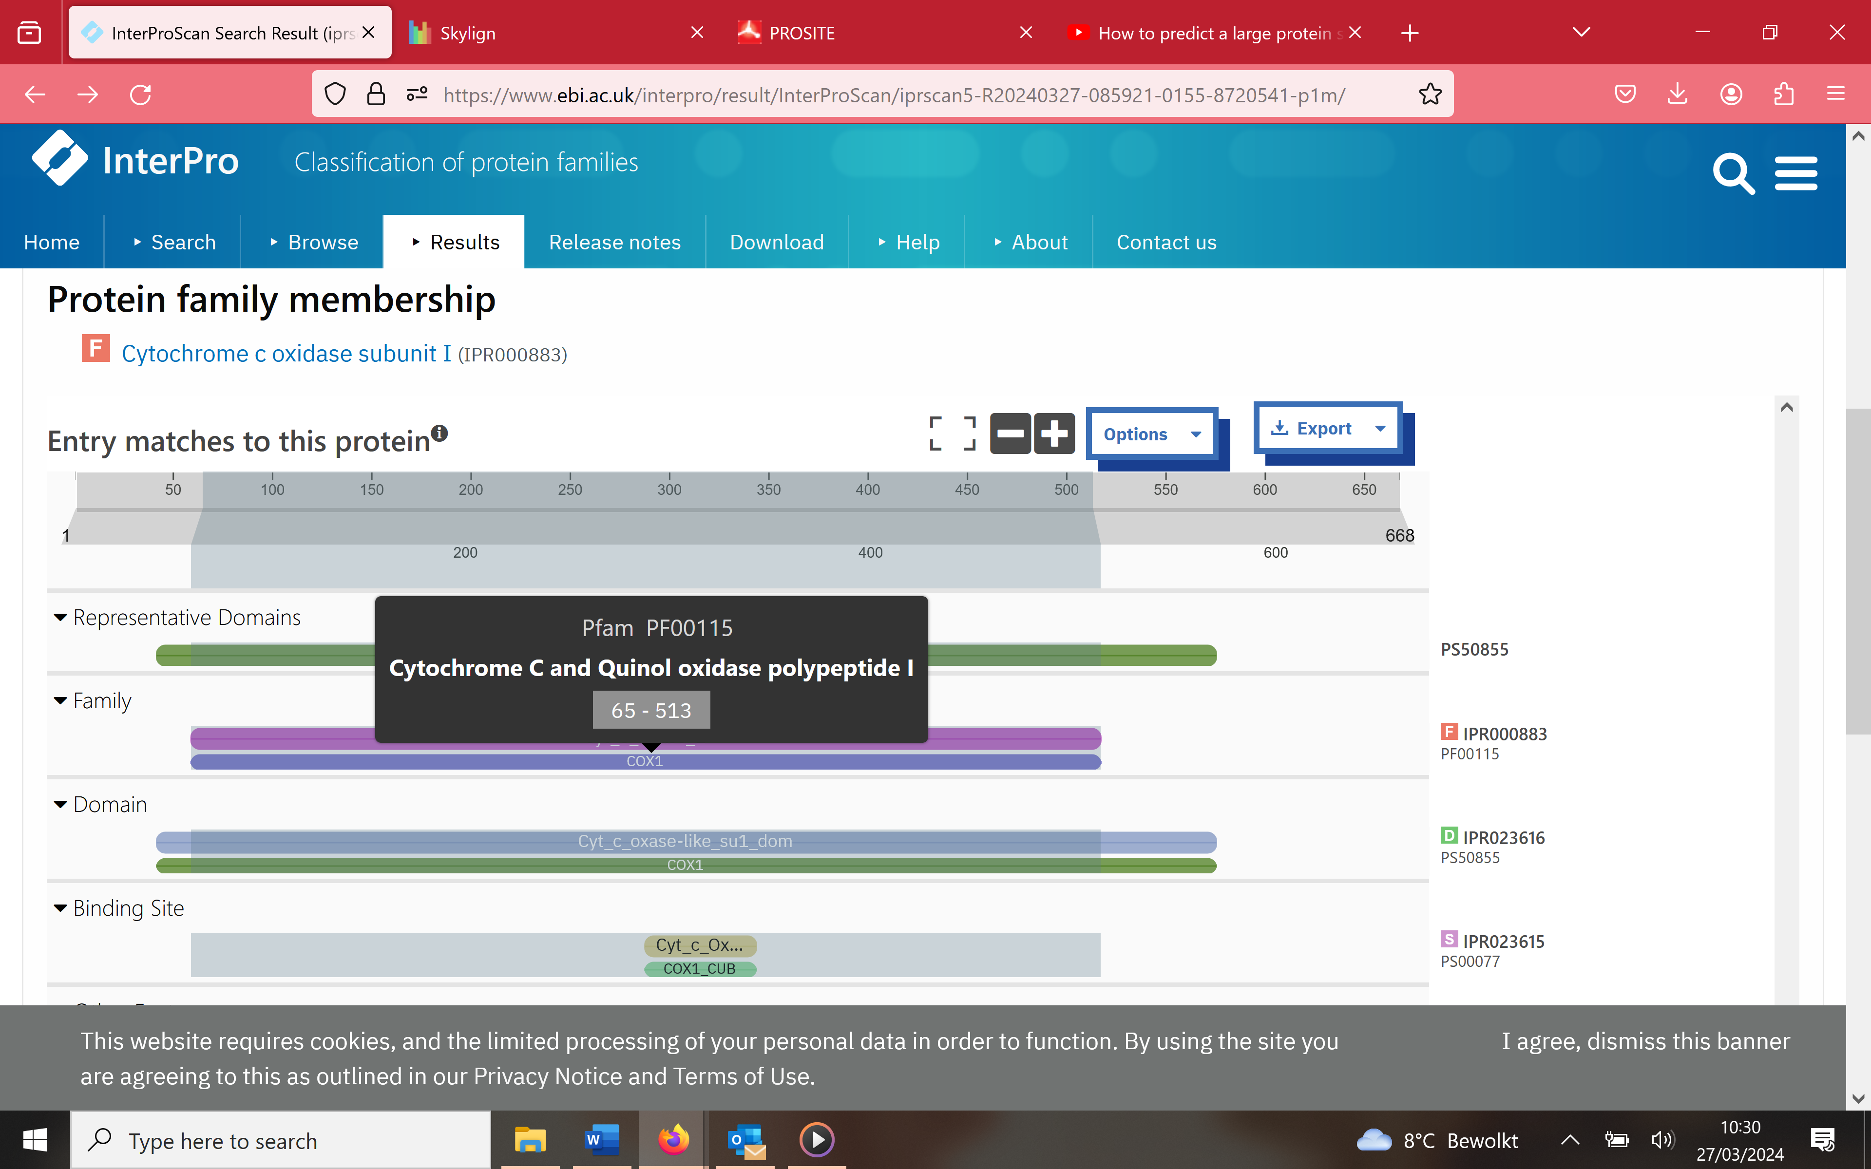

Click on the red F at the right of the sequence. Tis brings you to the interpro site with the information of PFAM. From there you can go to the original pfam database.

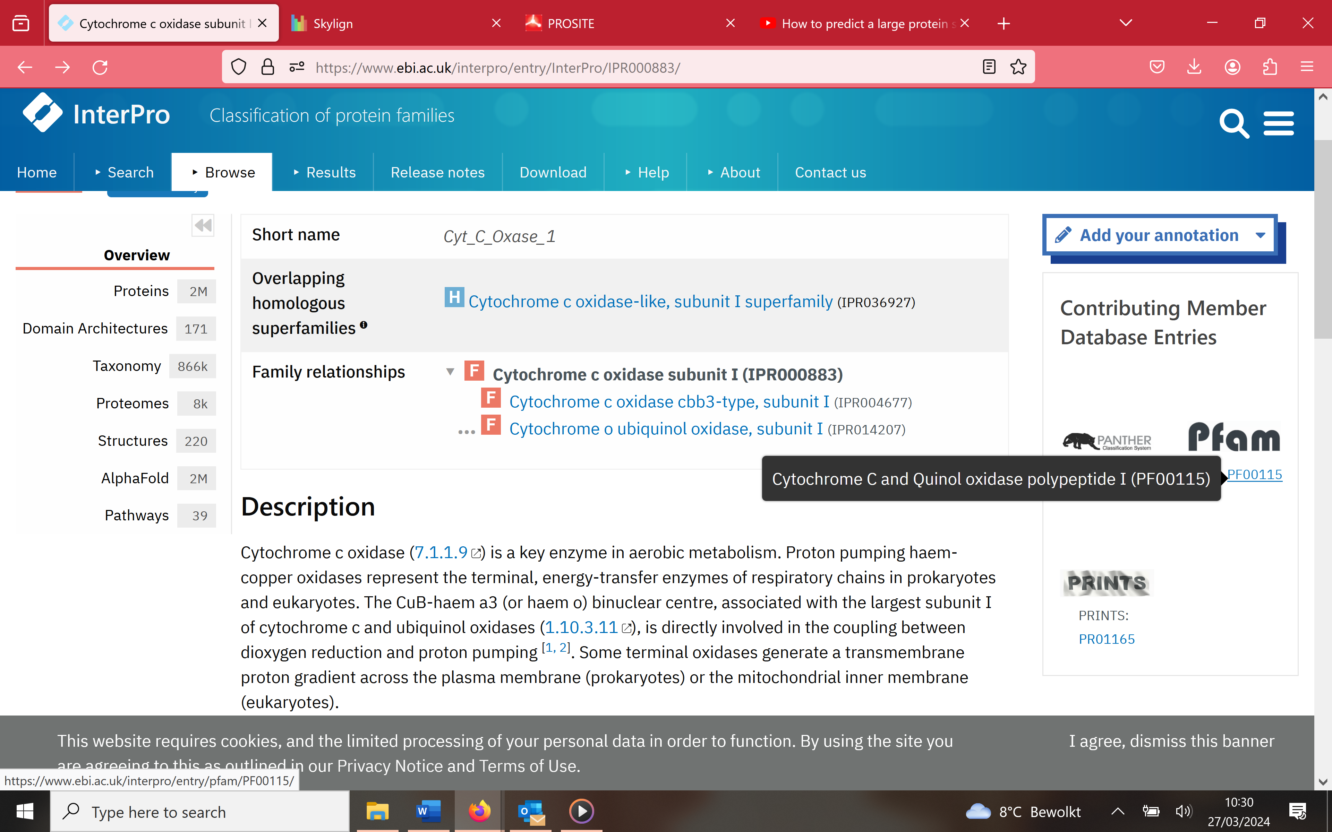

## Homology Search by patterns and profiles (PROSITE)

Go to the original prosite profile database from a scan in interpro

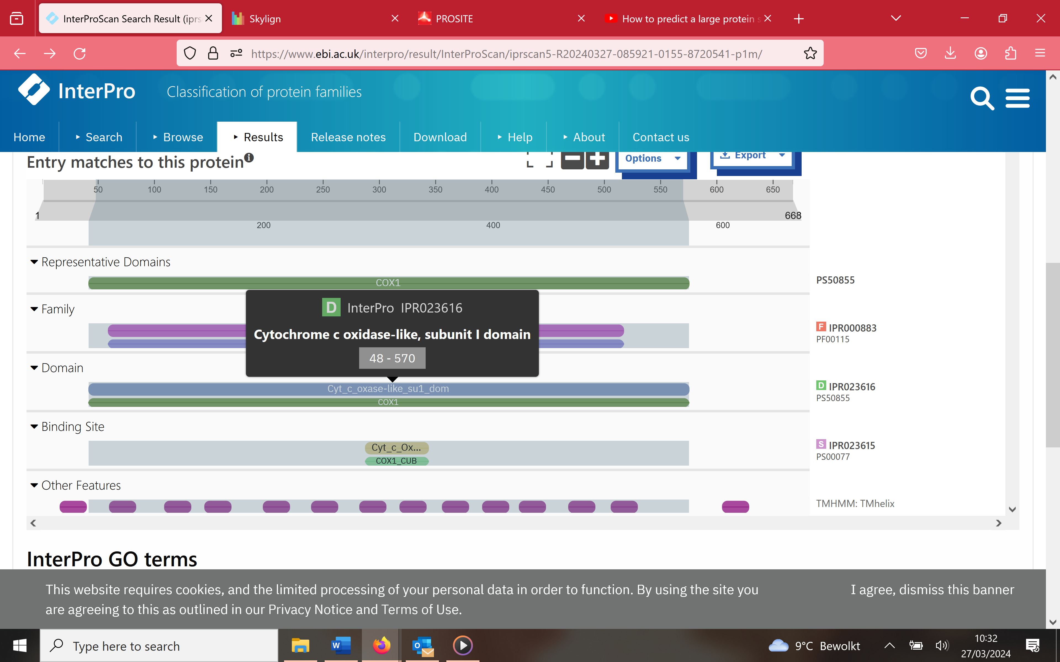

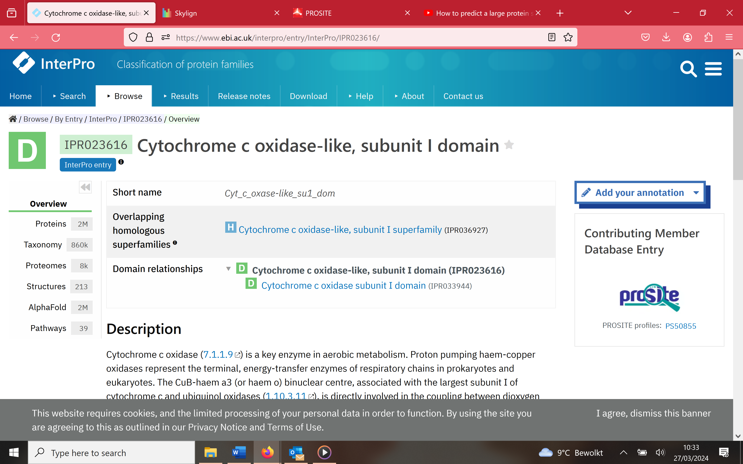

First you observe a general overview of the protein family. Enter in prosite to see the profile

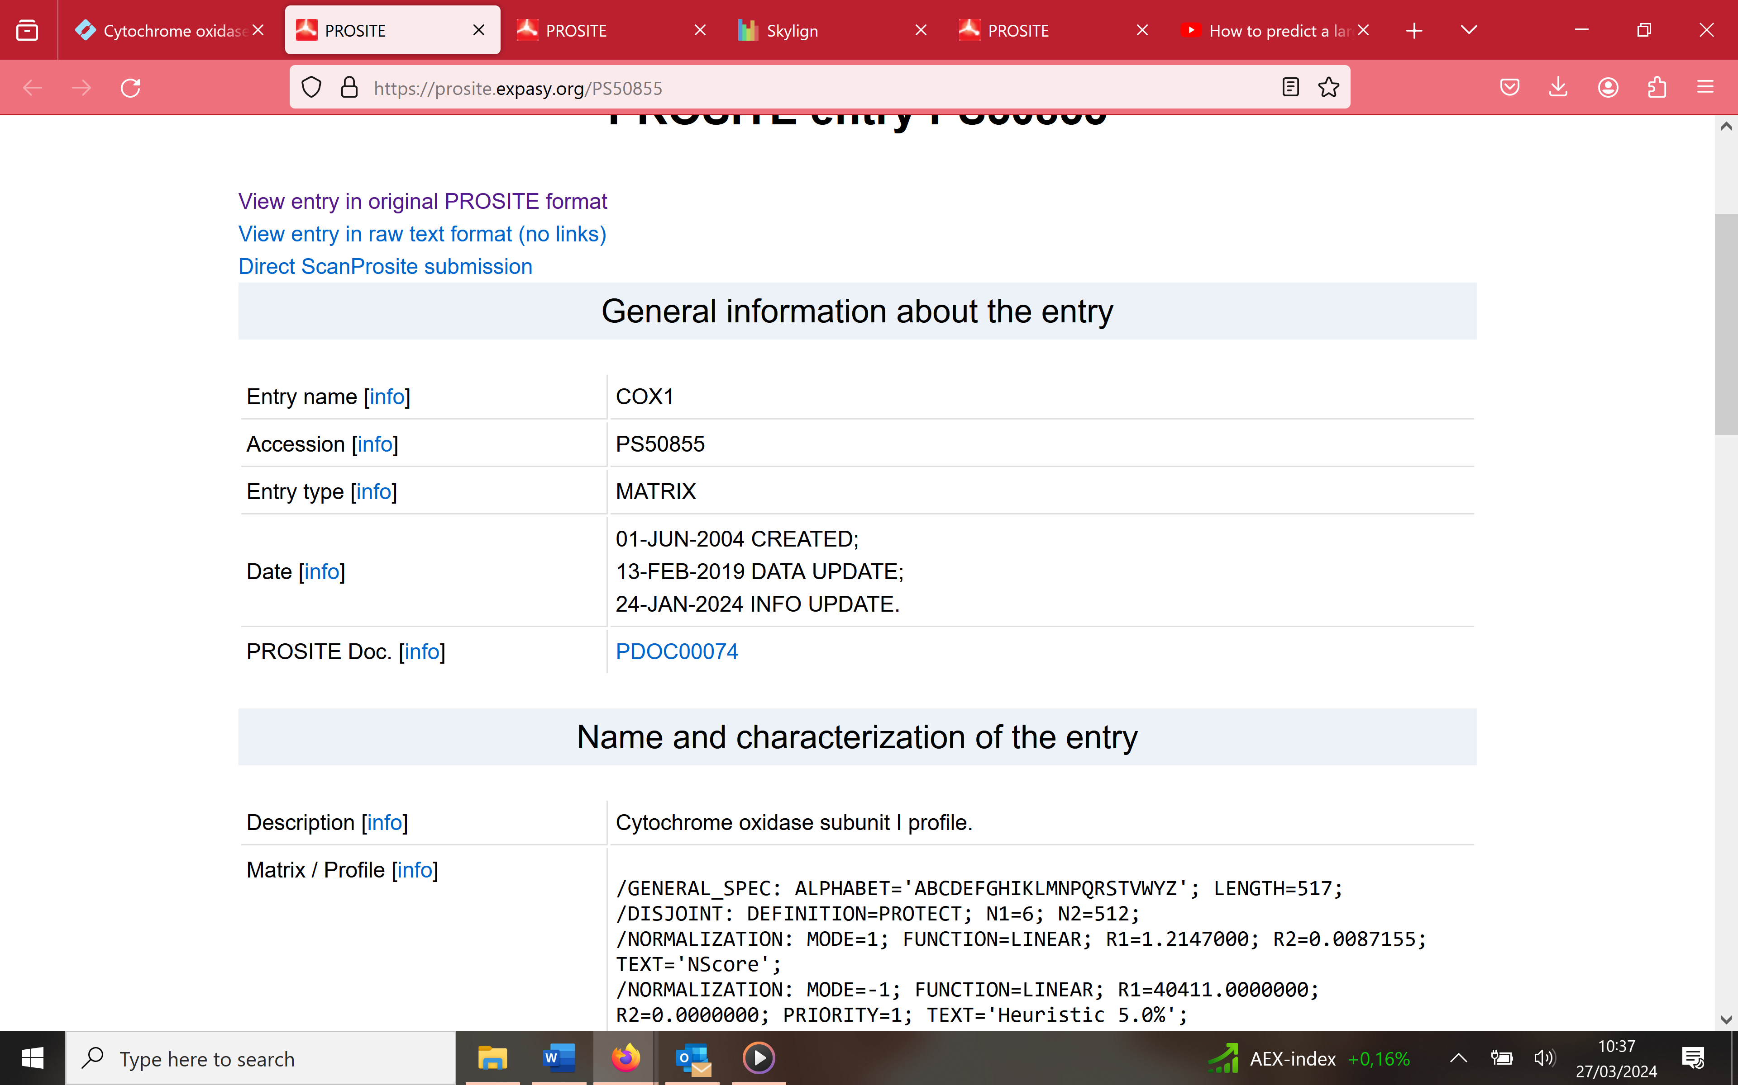

Check how many sequences were used to generate the profile:

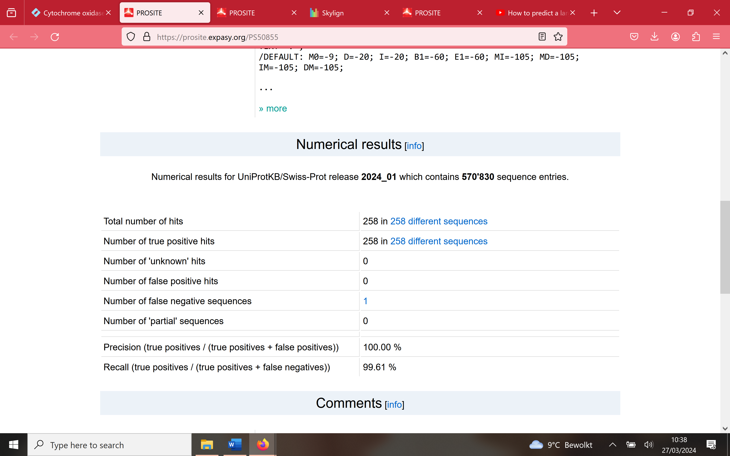

Altermatively we can use the original prosite scan

https://pros ite.expasy.org/

**Perform a quick scan using the Scan Prosite form.**

You obtain matches with prosite **profiles** and **patterns**. What is the difference between both?

*Form to scan your sequence with the PROSITE database*

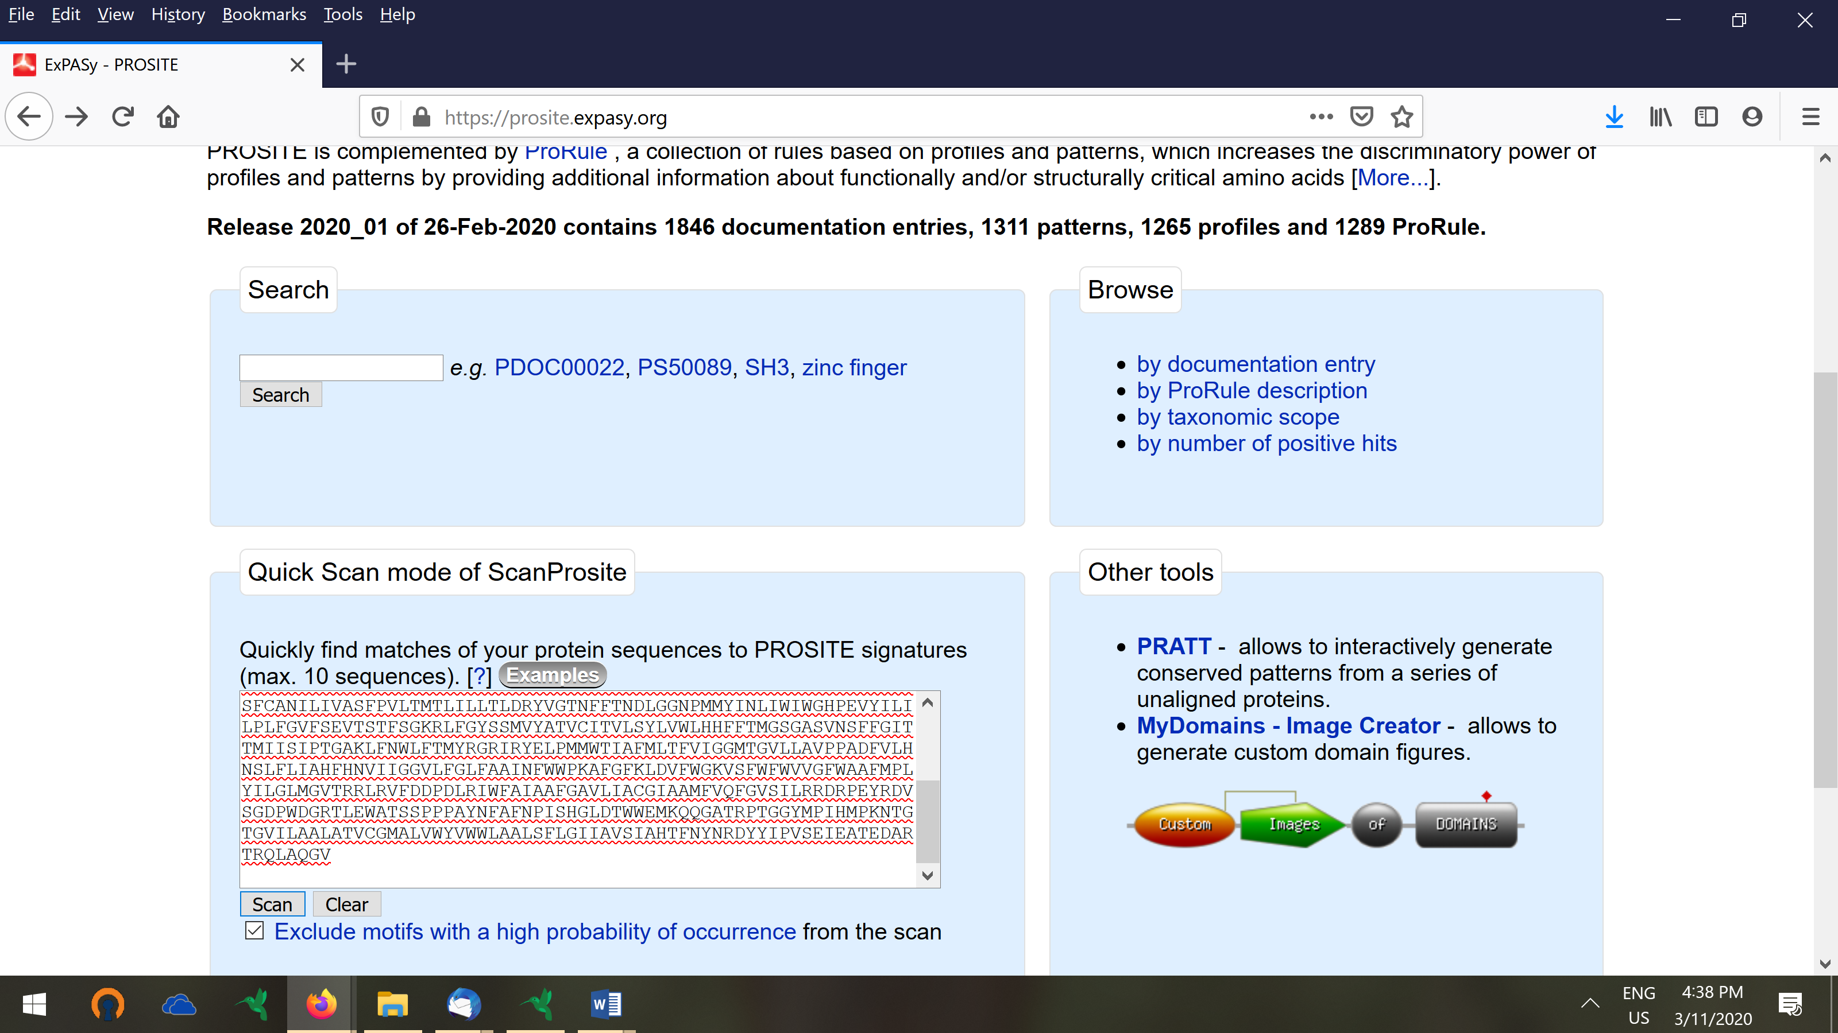

*Results obtained by PROSITE: Retrieved hits are defined as ‘profiles and patterns’*

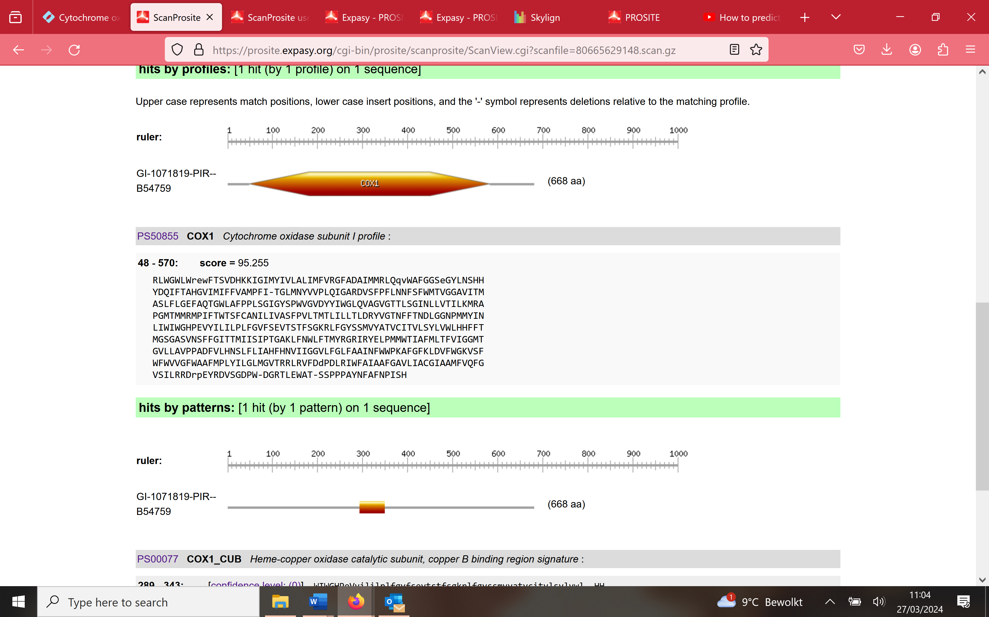

**Focusing on the patterns**

Prosite found a hit with 1 pattern (with accessnumber PS00077). So between position 289 and 343 there is a hit with the prosite pattern in your sequence. The sequence displayed is the instance of the pattern in your query sequence. You see that the pattern contains the two conserved HH relevant for heme binding that are also in the multiple alignment (see above). It thus is the expected pattern. Click on the link PSS0007. You will now see information on the pattern (with what type of functionality can it be associated). If you scroll down on this page you will see the technical information. It is the description of the pattern. So you can see that a pattern here refers to a string based representation of the motif i.e. a regular expression. A prosite pattern thus is a regular expression.

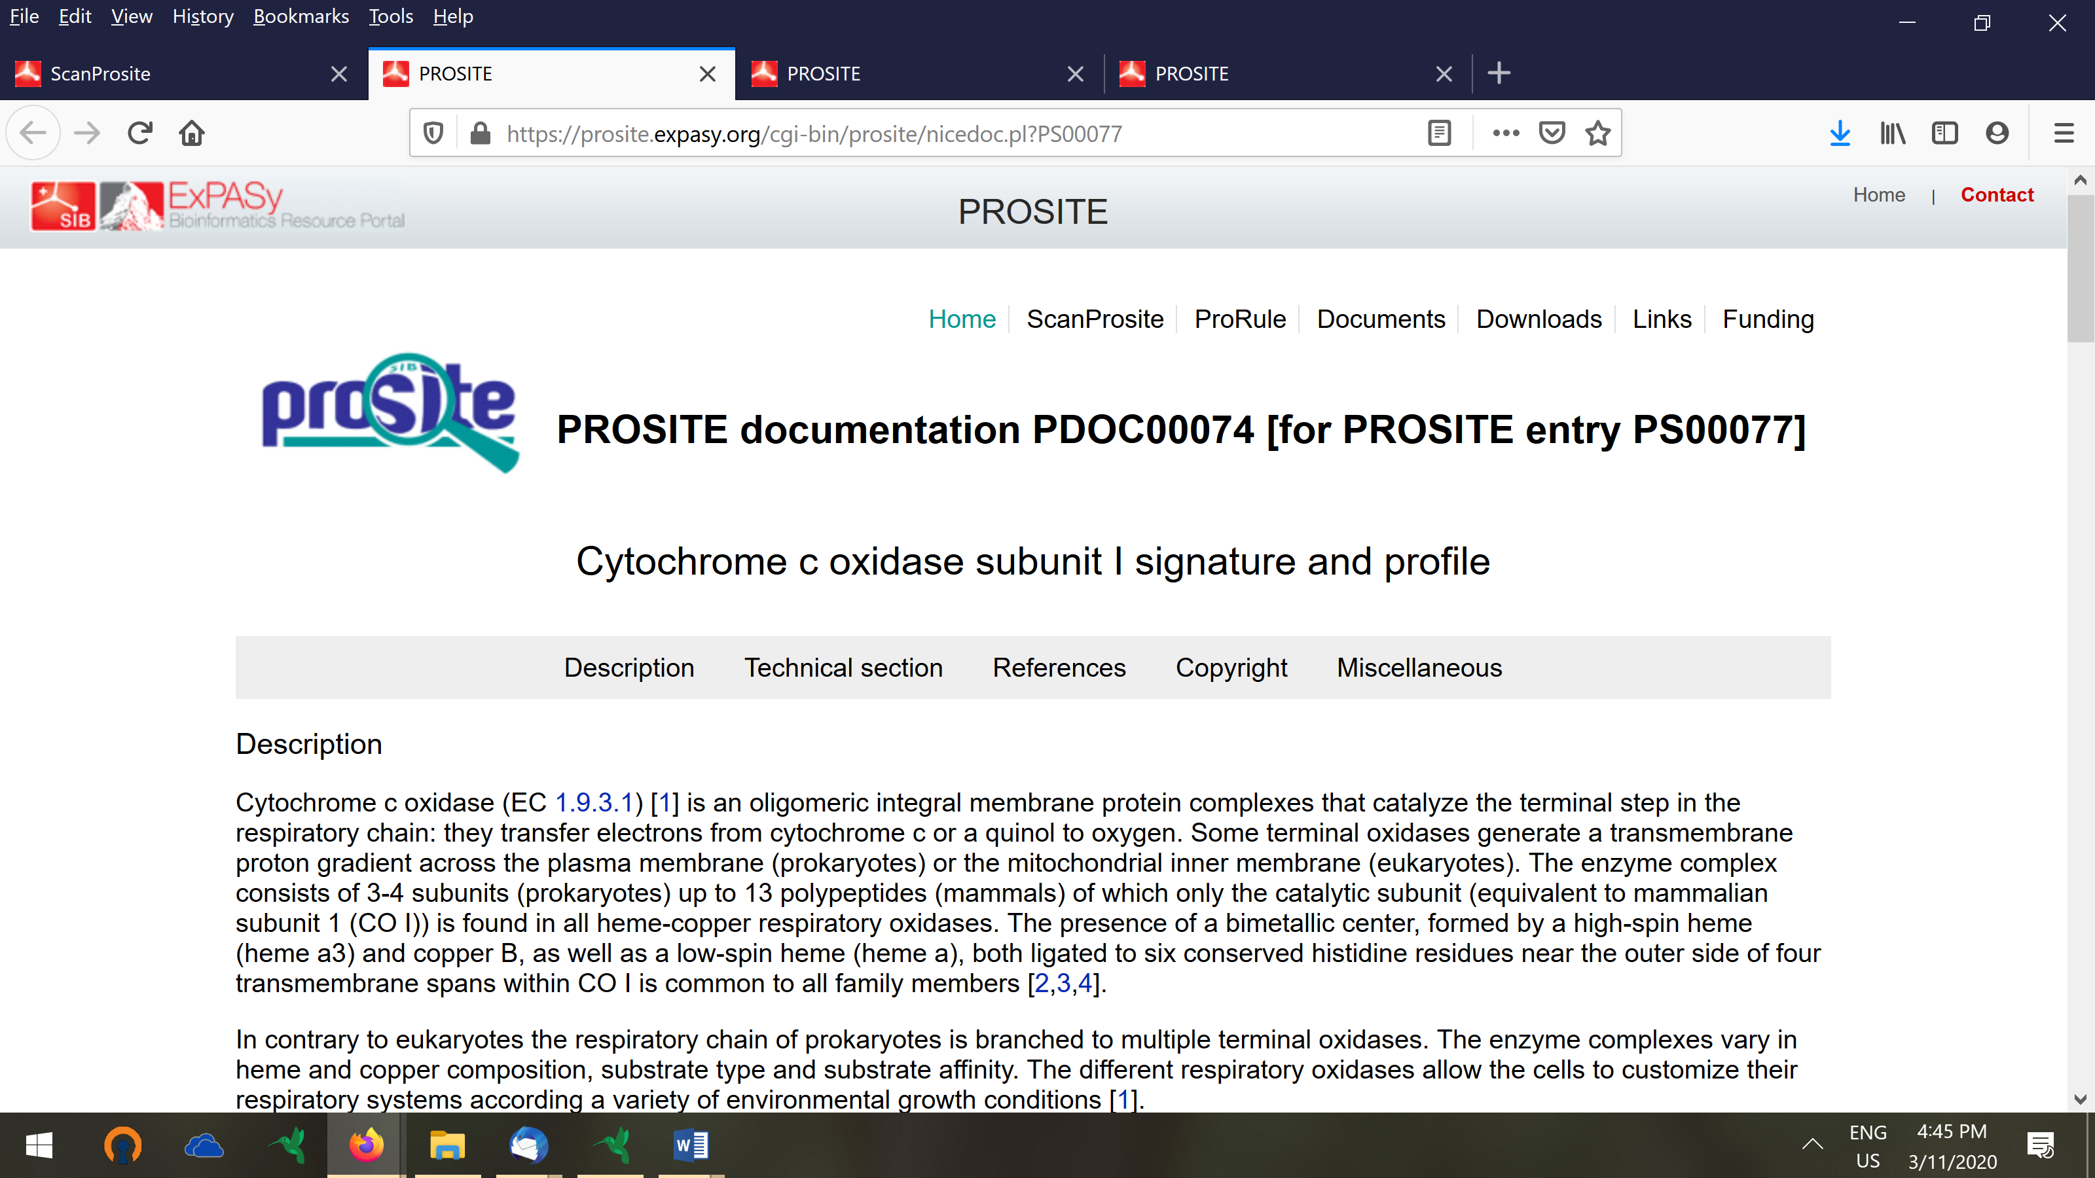

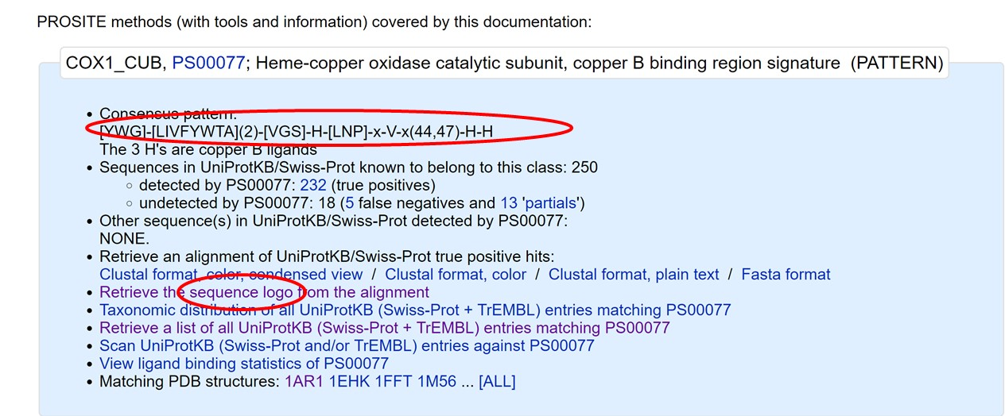

Consensus pattern:  
[YWG]-[LIVFYWTA](2)-[VGS]-H-[LNP]-x-V-x(44,47)-H-H

**Focusing on the profiles:**

The profile that is detected in your sequence is indicated with the accession PS50855.



If you click on the link

<https://prosite.expasy.org/cgi-bin/prosite/nicedoc.pl?PS50855>. You get the description on the biological meaning of the profile. This is the same as for the pattern. This is to be expected because the profile and the pattern represent the same region in the sequence. They are derived from the same multiple alignment of proteins. Just the pattern is a string based representation (regular expression) whereas the profile is a probabilistic representation ‘profile representation’ of the theory. Check out the technical description of the profile and see whether you can interpret this (if needed check the theory on profiles and the explanation given there). See slide 33 presentatie_Motif_representation_Marchal_2020_part1. You need to be able to understand what the different columns/rows mean in the model.

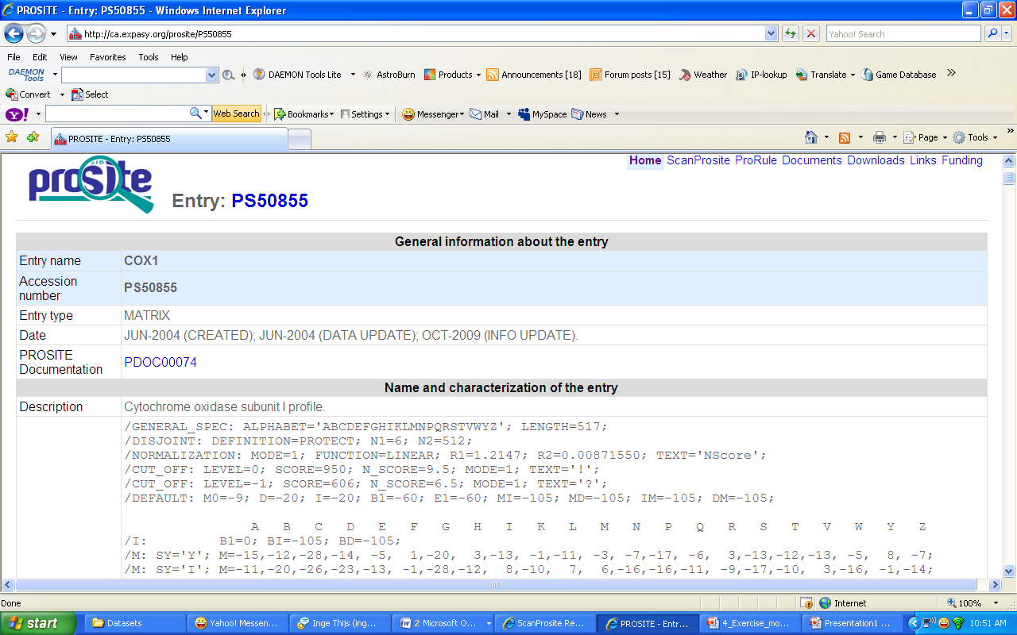

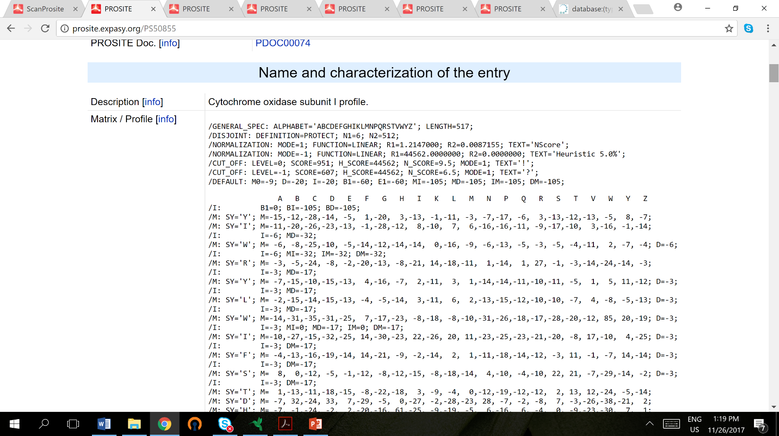

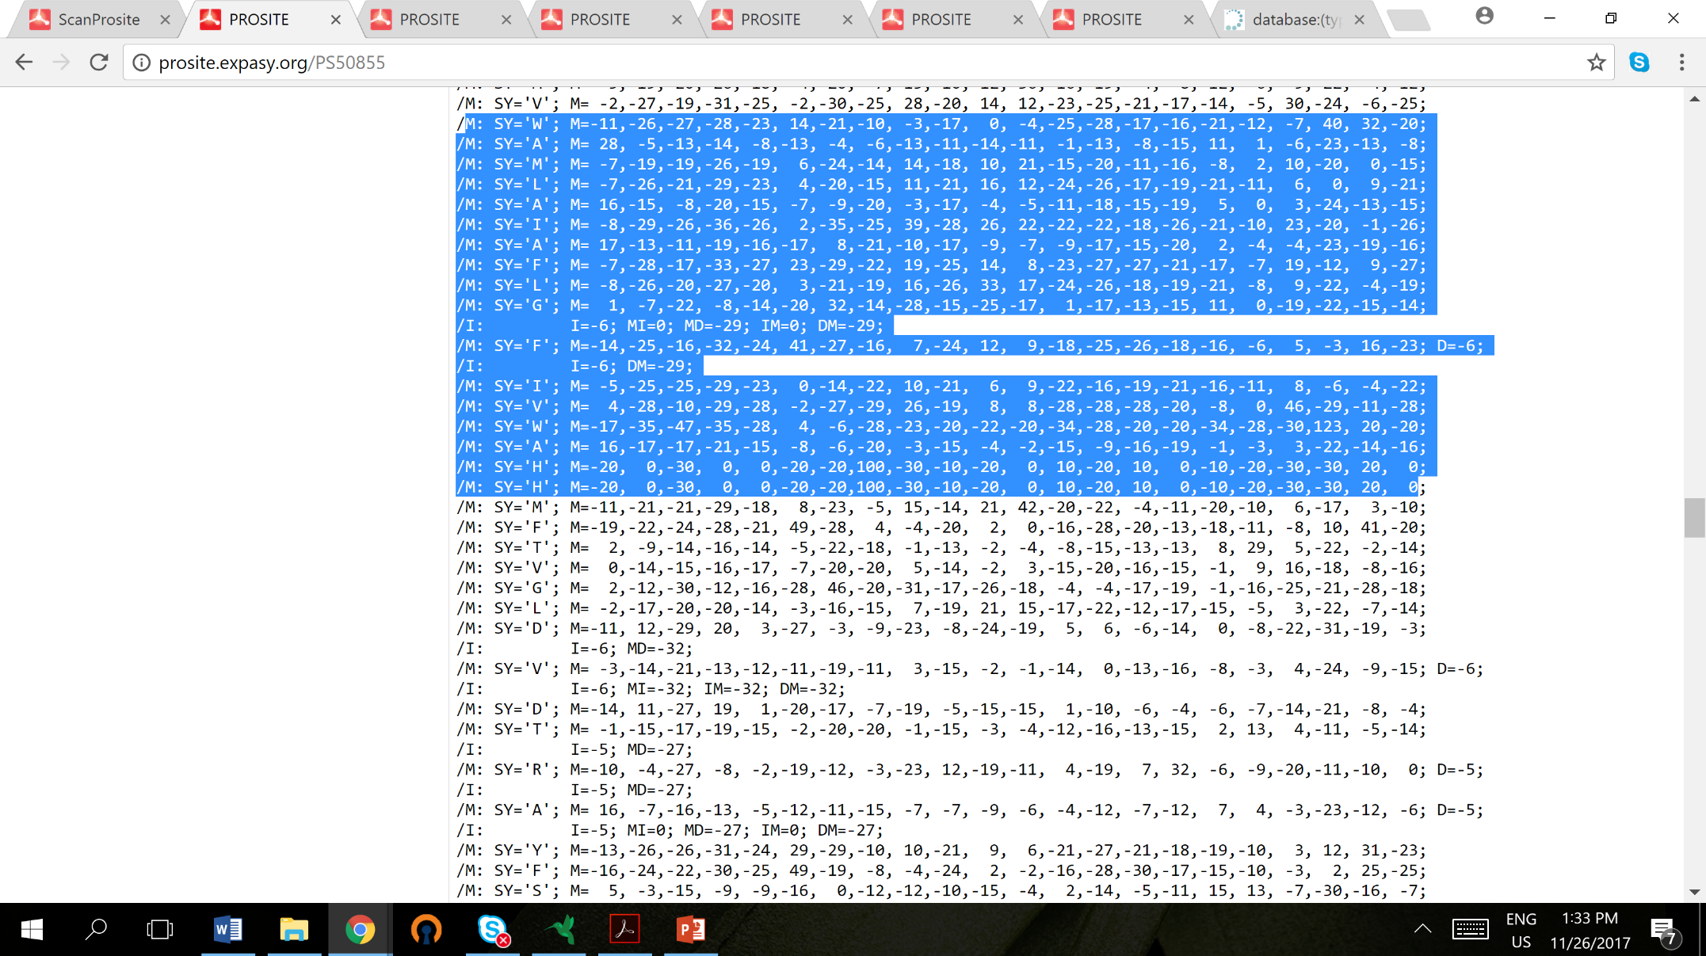

The alphabet

How are the profiles generated (look up in the theory). Profiles are longer than patterns (see example, how long is the profile (517 characters). The conserved region in the multiple alignment that is also captured by the pattern is indicated in blue. This is also the region for which the logo is displayed.

Show the logo of the profile and show the profile (interpret it)

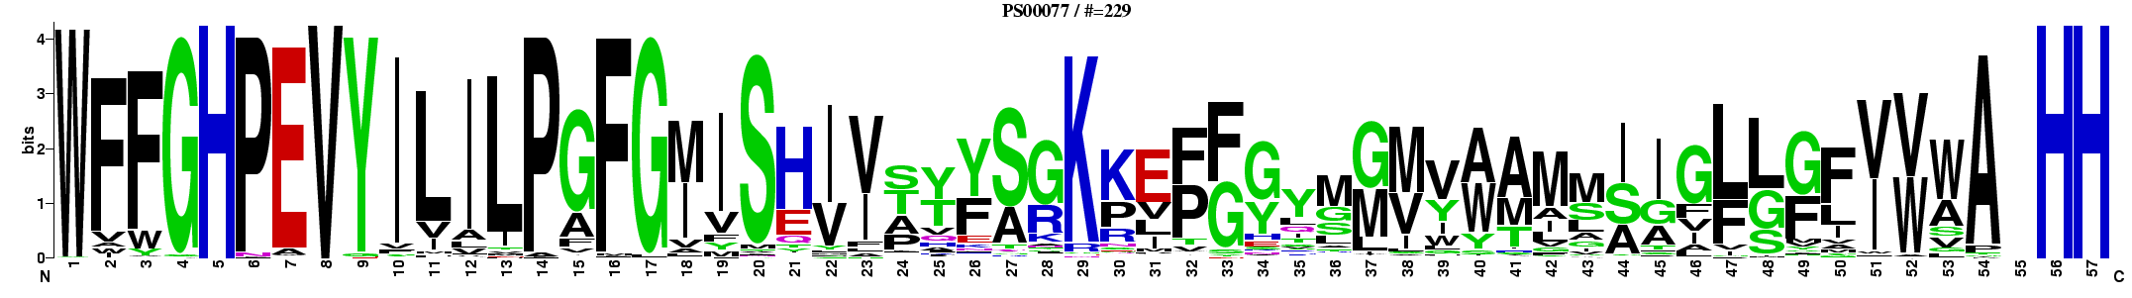

Note that the motif logo is built in the same way as for nucleotide motifs except that we use Di= log2(20)-Hi. So suppose a position in the alignment is perfectly conserved (fbi=1)=> then the score becomes log2(20)-1Xlog2(1) -0Xlog2(0). => 1Xlog2(1) = 0 and 0Xlog2(0) approximates 0 (if there are only pseudocunts). So the max stack hight of a column is log2(20) = 4.3 (not accounting for psuedocounts)



See also the explanation on slide 30: the higher the stack the more conserved the position + the relative hight of the letters at a position describes their relative degree of conservation -> In case there are 2 letters in a stack (for ex. In the beginning of the seq. There is a big F and smaller W underneath, does it mean that the F on that position is more conserved and more frequently occurs on that position than the W and that W occurs less frequently and is not as conserved as F. This is correct interpretation by a student!

Show also the multiple alignment from which the profile and the pattern were derived (see below-> this function does not always work on the prosite server)

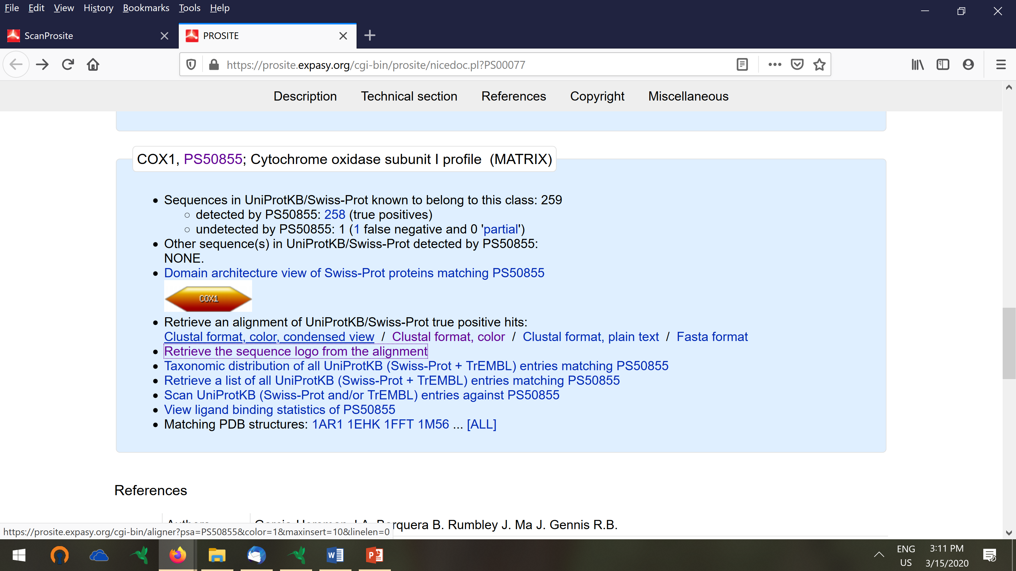

Conclusion: this exercise illustrated one of the important protein databases (prosite). Prosite summarizes conserved regions in protein families by patterns and profiles. You can screen an unknown sequence against the prosite database to have an indication as to which conserved domains are present (prosite performs a screening with both its database of patterns and profiles. This can give you a hint on the function of your query protein. You should be able to interpret the representations.

## Homology Search by HMM (PFAM) profiling

For a description of PFAM see course notes. Pfam is a database that contains HMM profiles for several protein families.

Perform a sequence search. This has become obsolete I keep the out put of the original PFAM (which is no longer shown as it is quite instructive to understand the bitscores and the e values. In the video of PFAM it is still explained.

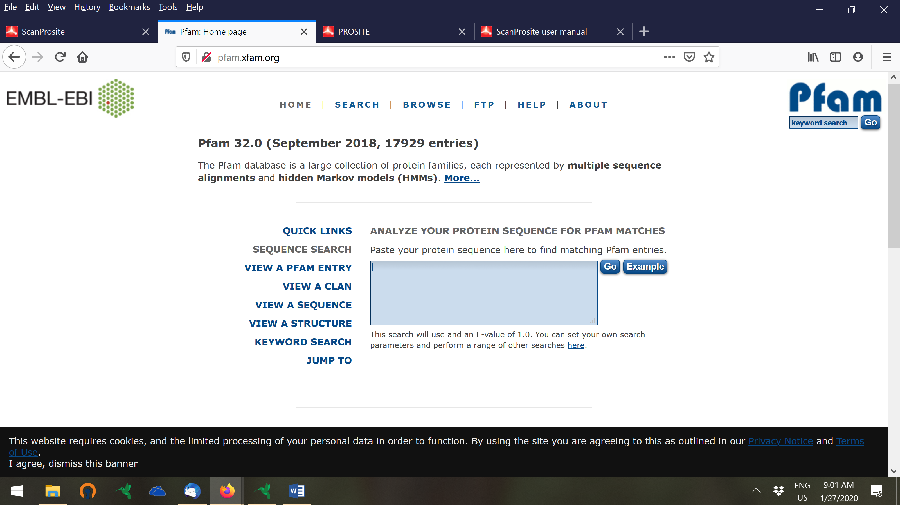

The search detected 3 PFAM –A matches (that are matches with verified/curated PFAM domains). There is one significant hit and two insignificant matches (matches with PFAm HMM models). The significance is indicated by the E. value. Focus on the significant hit. Click on the hit (cox) and view the results.



The left panel shows the information on the PFAM protein domain you detected. View for instance the domain organization. The remainder of the information is still shown in the new version of interpro.

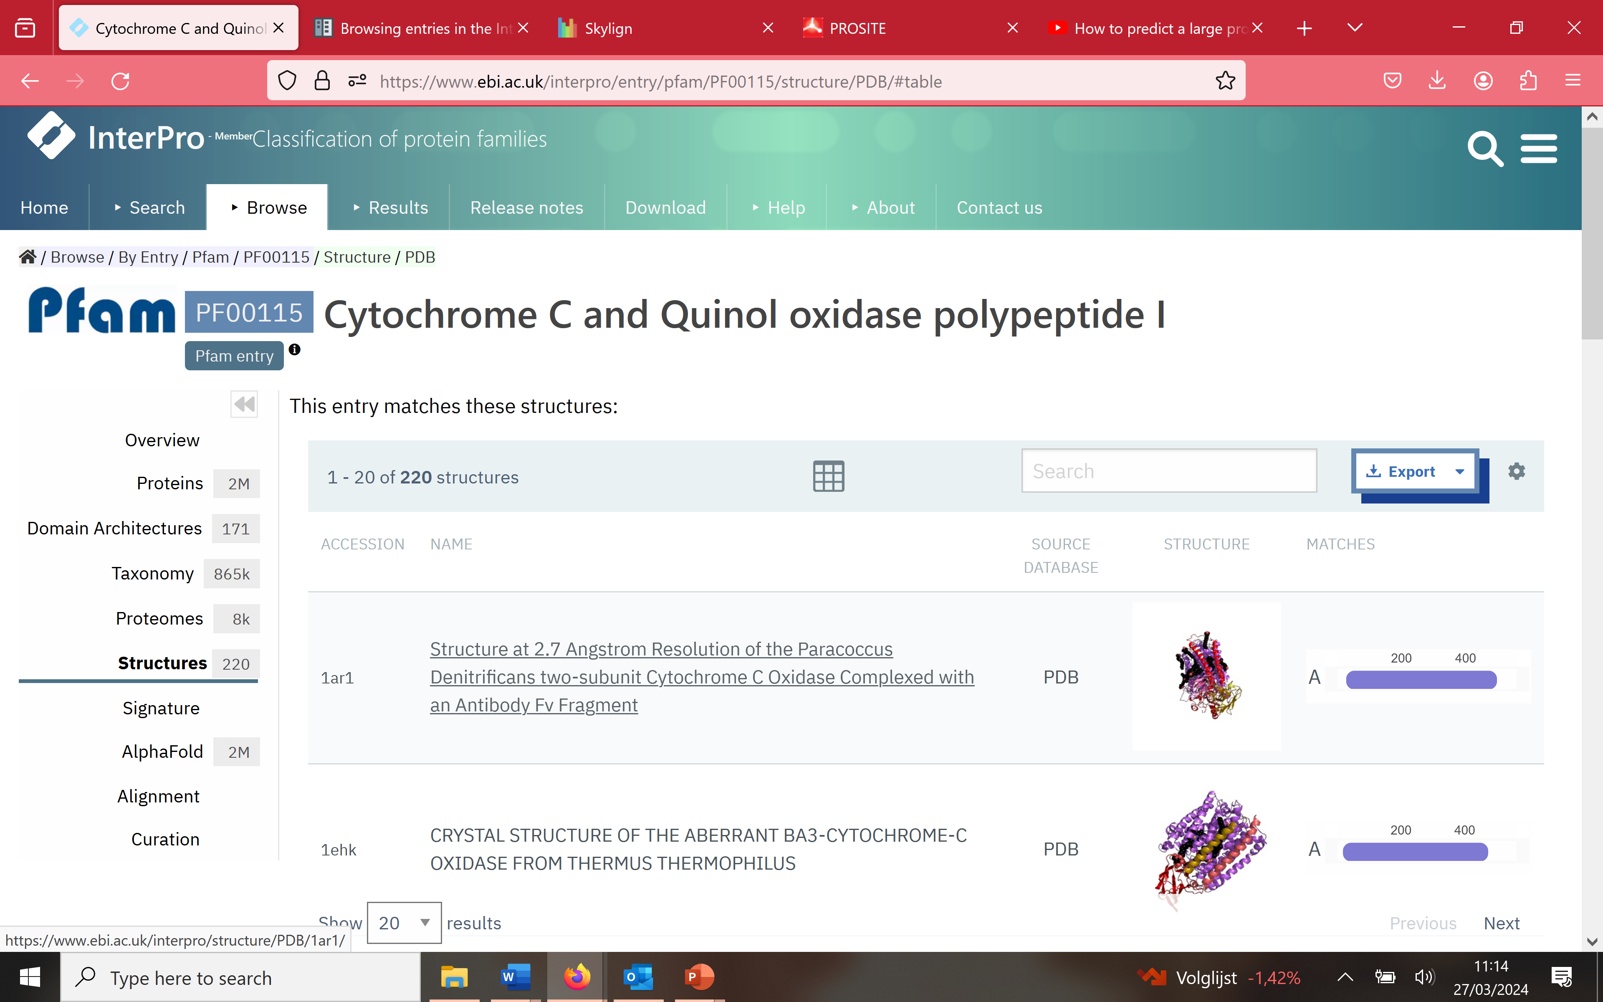

Structural information on the domain

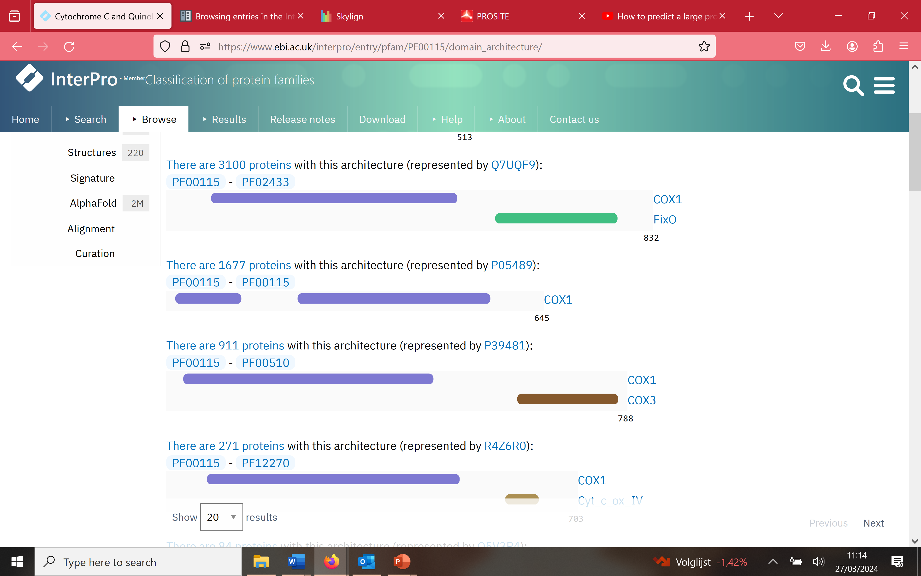

The figure above shows you how the proteins that belong to the cox family are organized in domains. Most proteins have only he cox1 domain but some have a combination of the cox1 with a fix domain or of the cox1 with cox1 with a cox3 domain. This shows how every protein is a compilation of different domains.

**View ‘alignments’.** These are the alignments that were used to generate the PFAM model. Alignments are provided in different formats (htmp, jalview, PP heatmap). Each time you can see an alignment of the ‘seed’ and the full alignment (see course notes). The full alignment contains all sequences that belong to the family whereas the “seed alignments” include fewer proteins which are sufficiently different to reflect the diversity of the members of each given Pfam family (representative sequences).

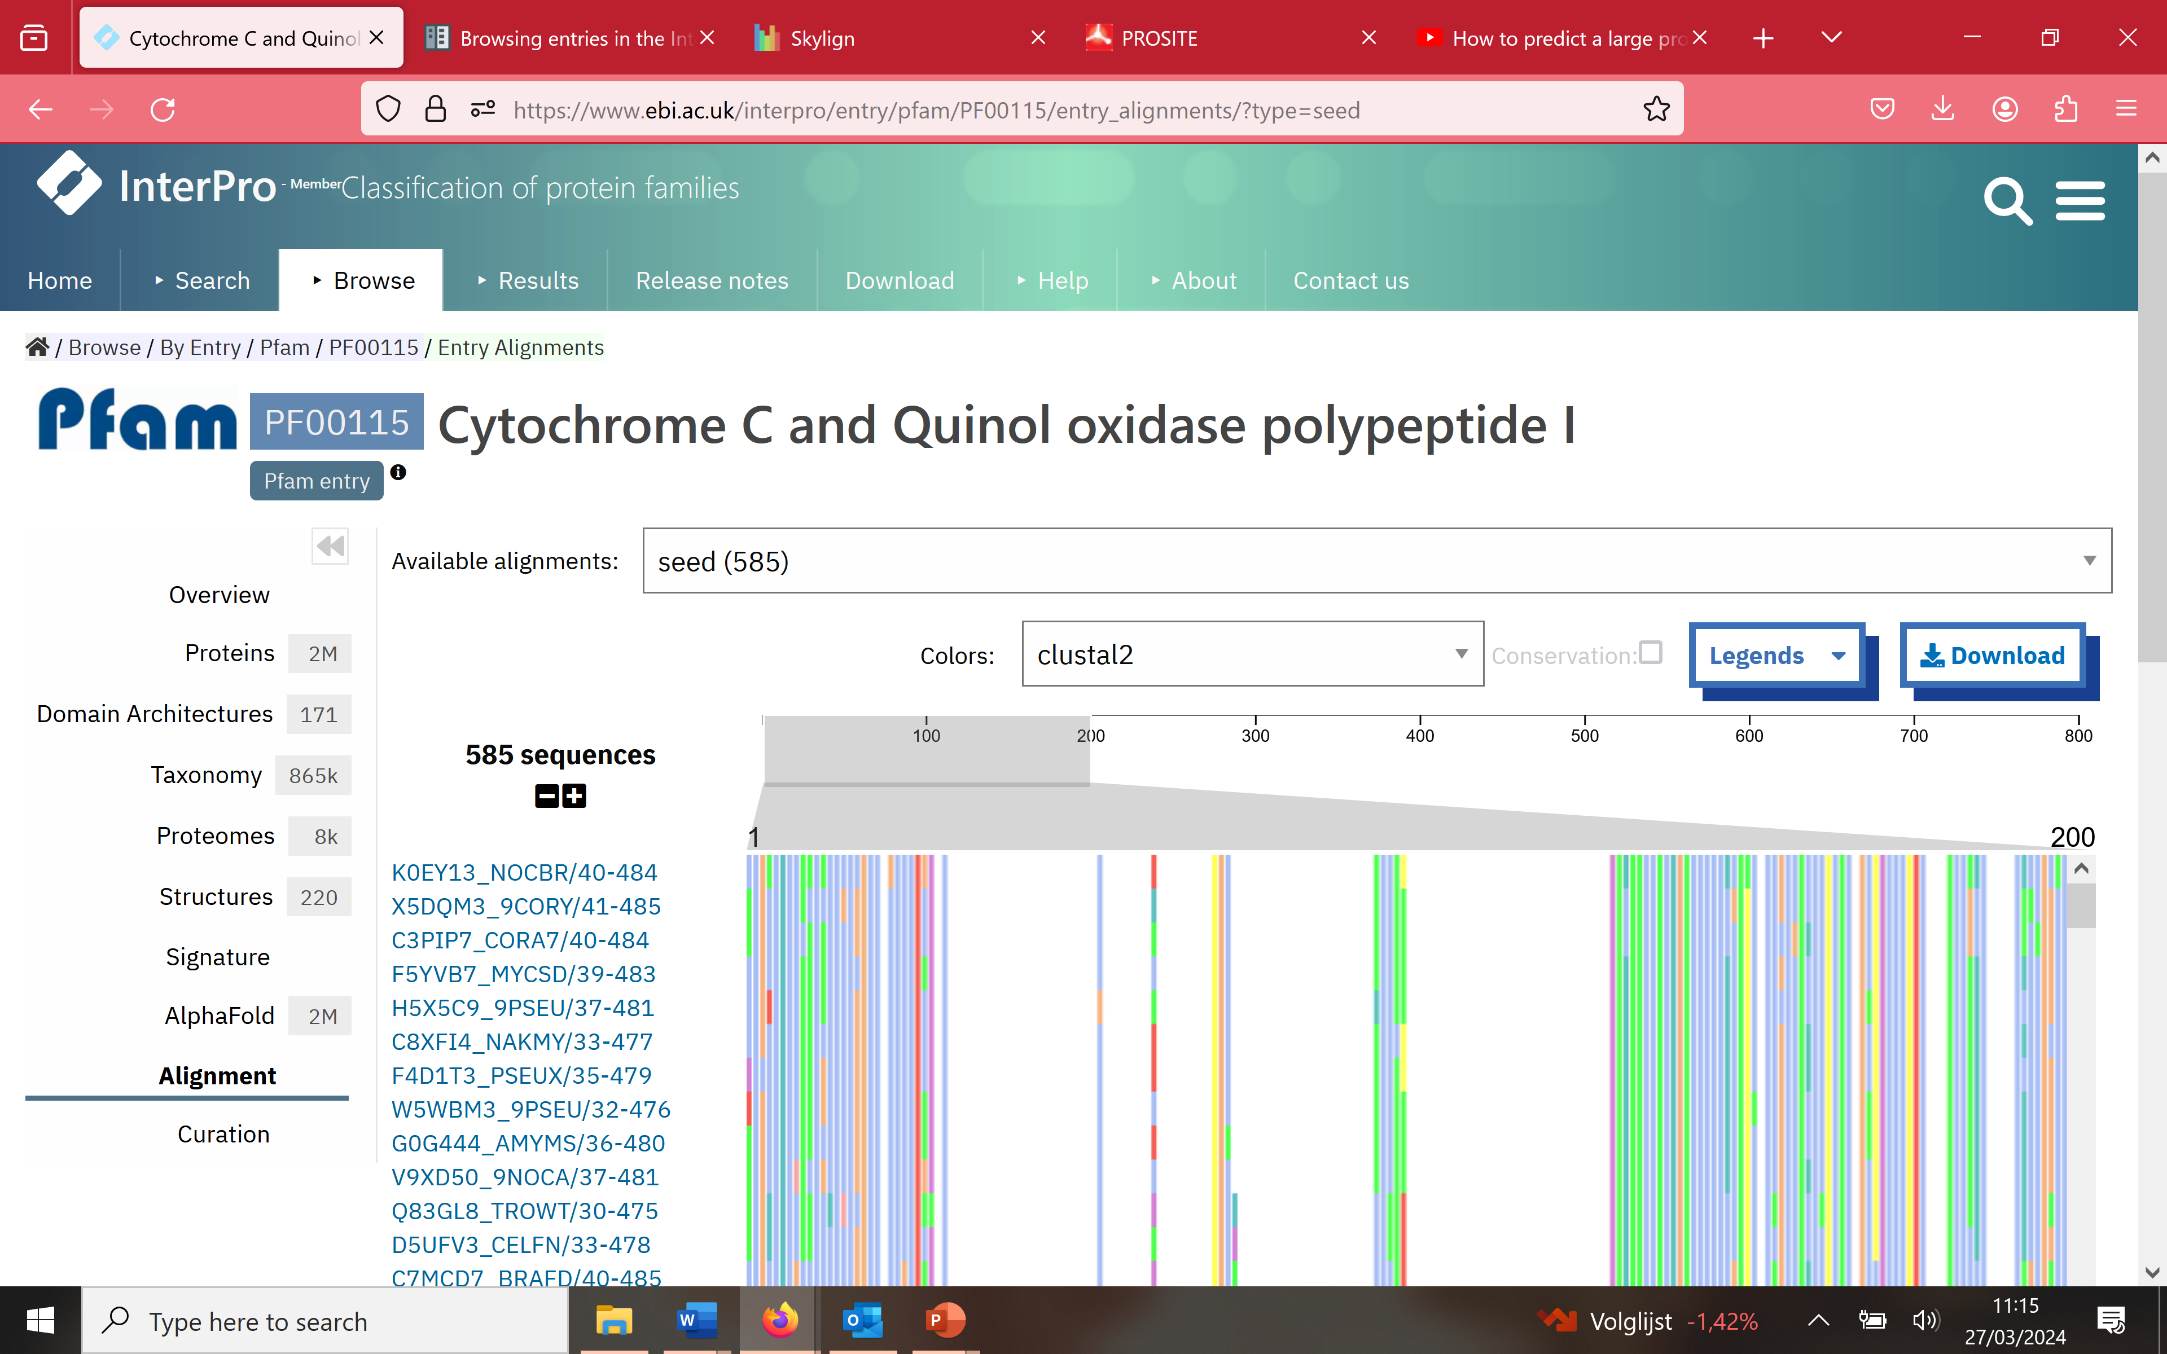

View the HMM Logo. More information on the logos in PFAM can be found here <https://bmcbioinformatics.biomedcentral.com/articles/10.1186/1471-2105-15-7>.

Here the relative entropy is used that takes into account the background model. I added this explanation to the course notes (updated version section in red).

Below is shown how to interpret the logo.



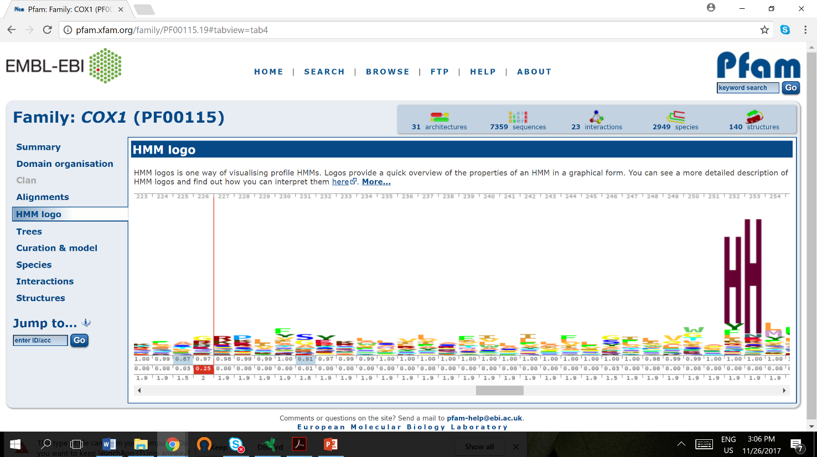

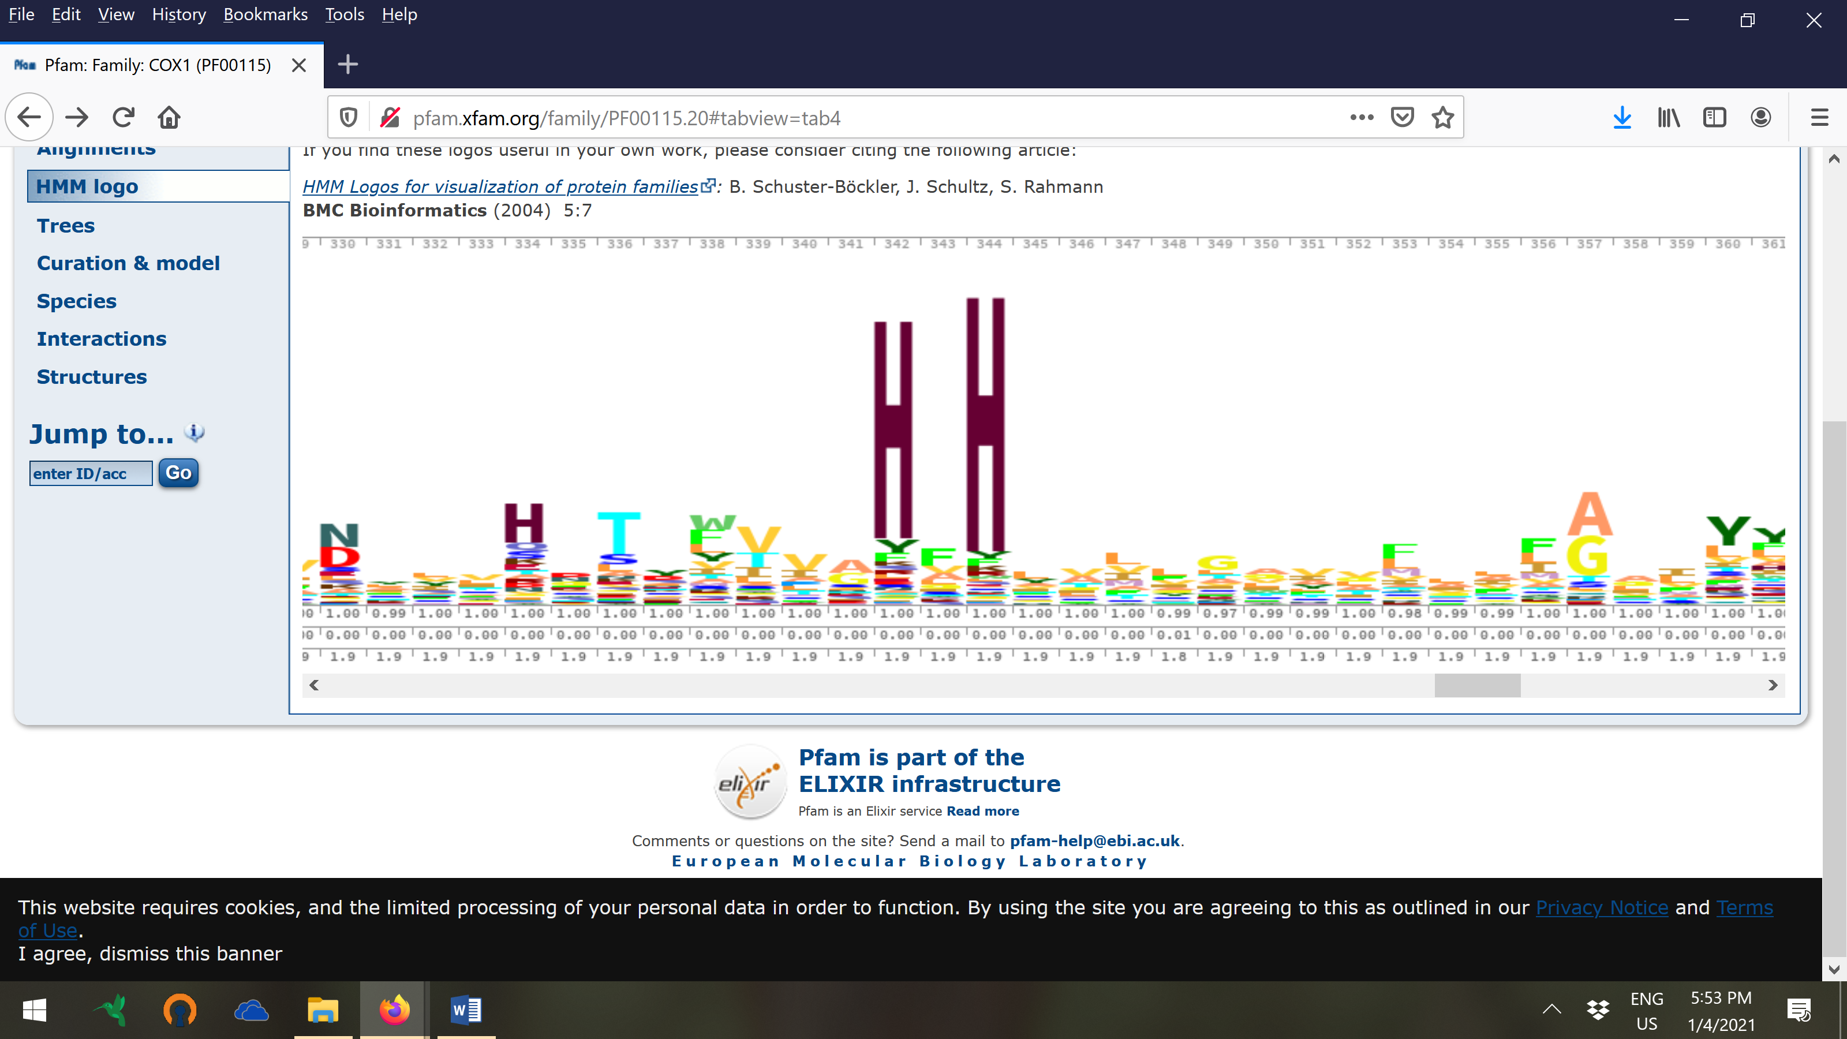

For information on how to build the logo:

<https://bmcbioinformatics.biomedcentral.com/articles/10.1186/1471-2105-15-7>

**Compare with the PROSITE pattern**



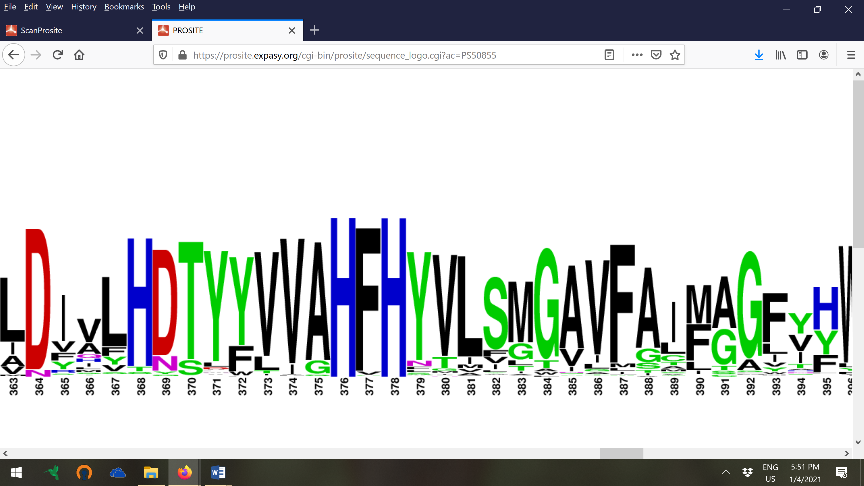

You can see that both prosite and the HMM represent the same domain but represented with a different underlying model.

The height of the stack is also a representation of how conserved a certain position is in the domain.  HMM logo shows that 2 His on position 252 and position 253 are very conserved and PROSITE pattern shows that those 2 His are also conserved and that they are the only amino acids that frequently occur on that position, compared to HMM logo where it is also possible to have other amino acids occur on that position with a lower frequency. This difference is related to the sequences that were used to build the motif model and/or the specific parameters to build the motif model (pseudocounts). The max stack height is e.g. the same for all conserved residues in the prosite profile but not in the HMM profile. This is because in the prosite profile the background frequencies of the amino acids is not accounted for (it uses the weblogo software we also used for the theoretical exercise) but in the HMM profile it is (HMM logo are built by skyline which is a different implementation). Overall it is visible that the same residues are conserved.

Note that below the HMM logo there are three additional lines with scores. This is because here not only a logo of the conserved region is shown but the logo accommodates for the probability of observing insertions and deletions. <https://bmcbioinformatics.biomedcentral.com/articles/10.1186/1471-2105-15-7> (you do not have to know the details).

**View in how many species the protein family occurs (5750)**

**View Species**

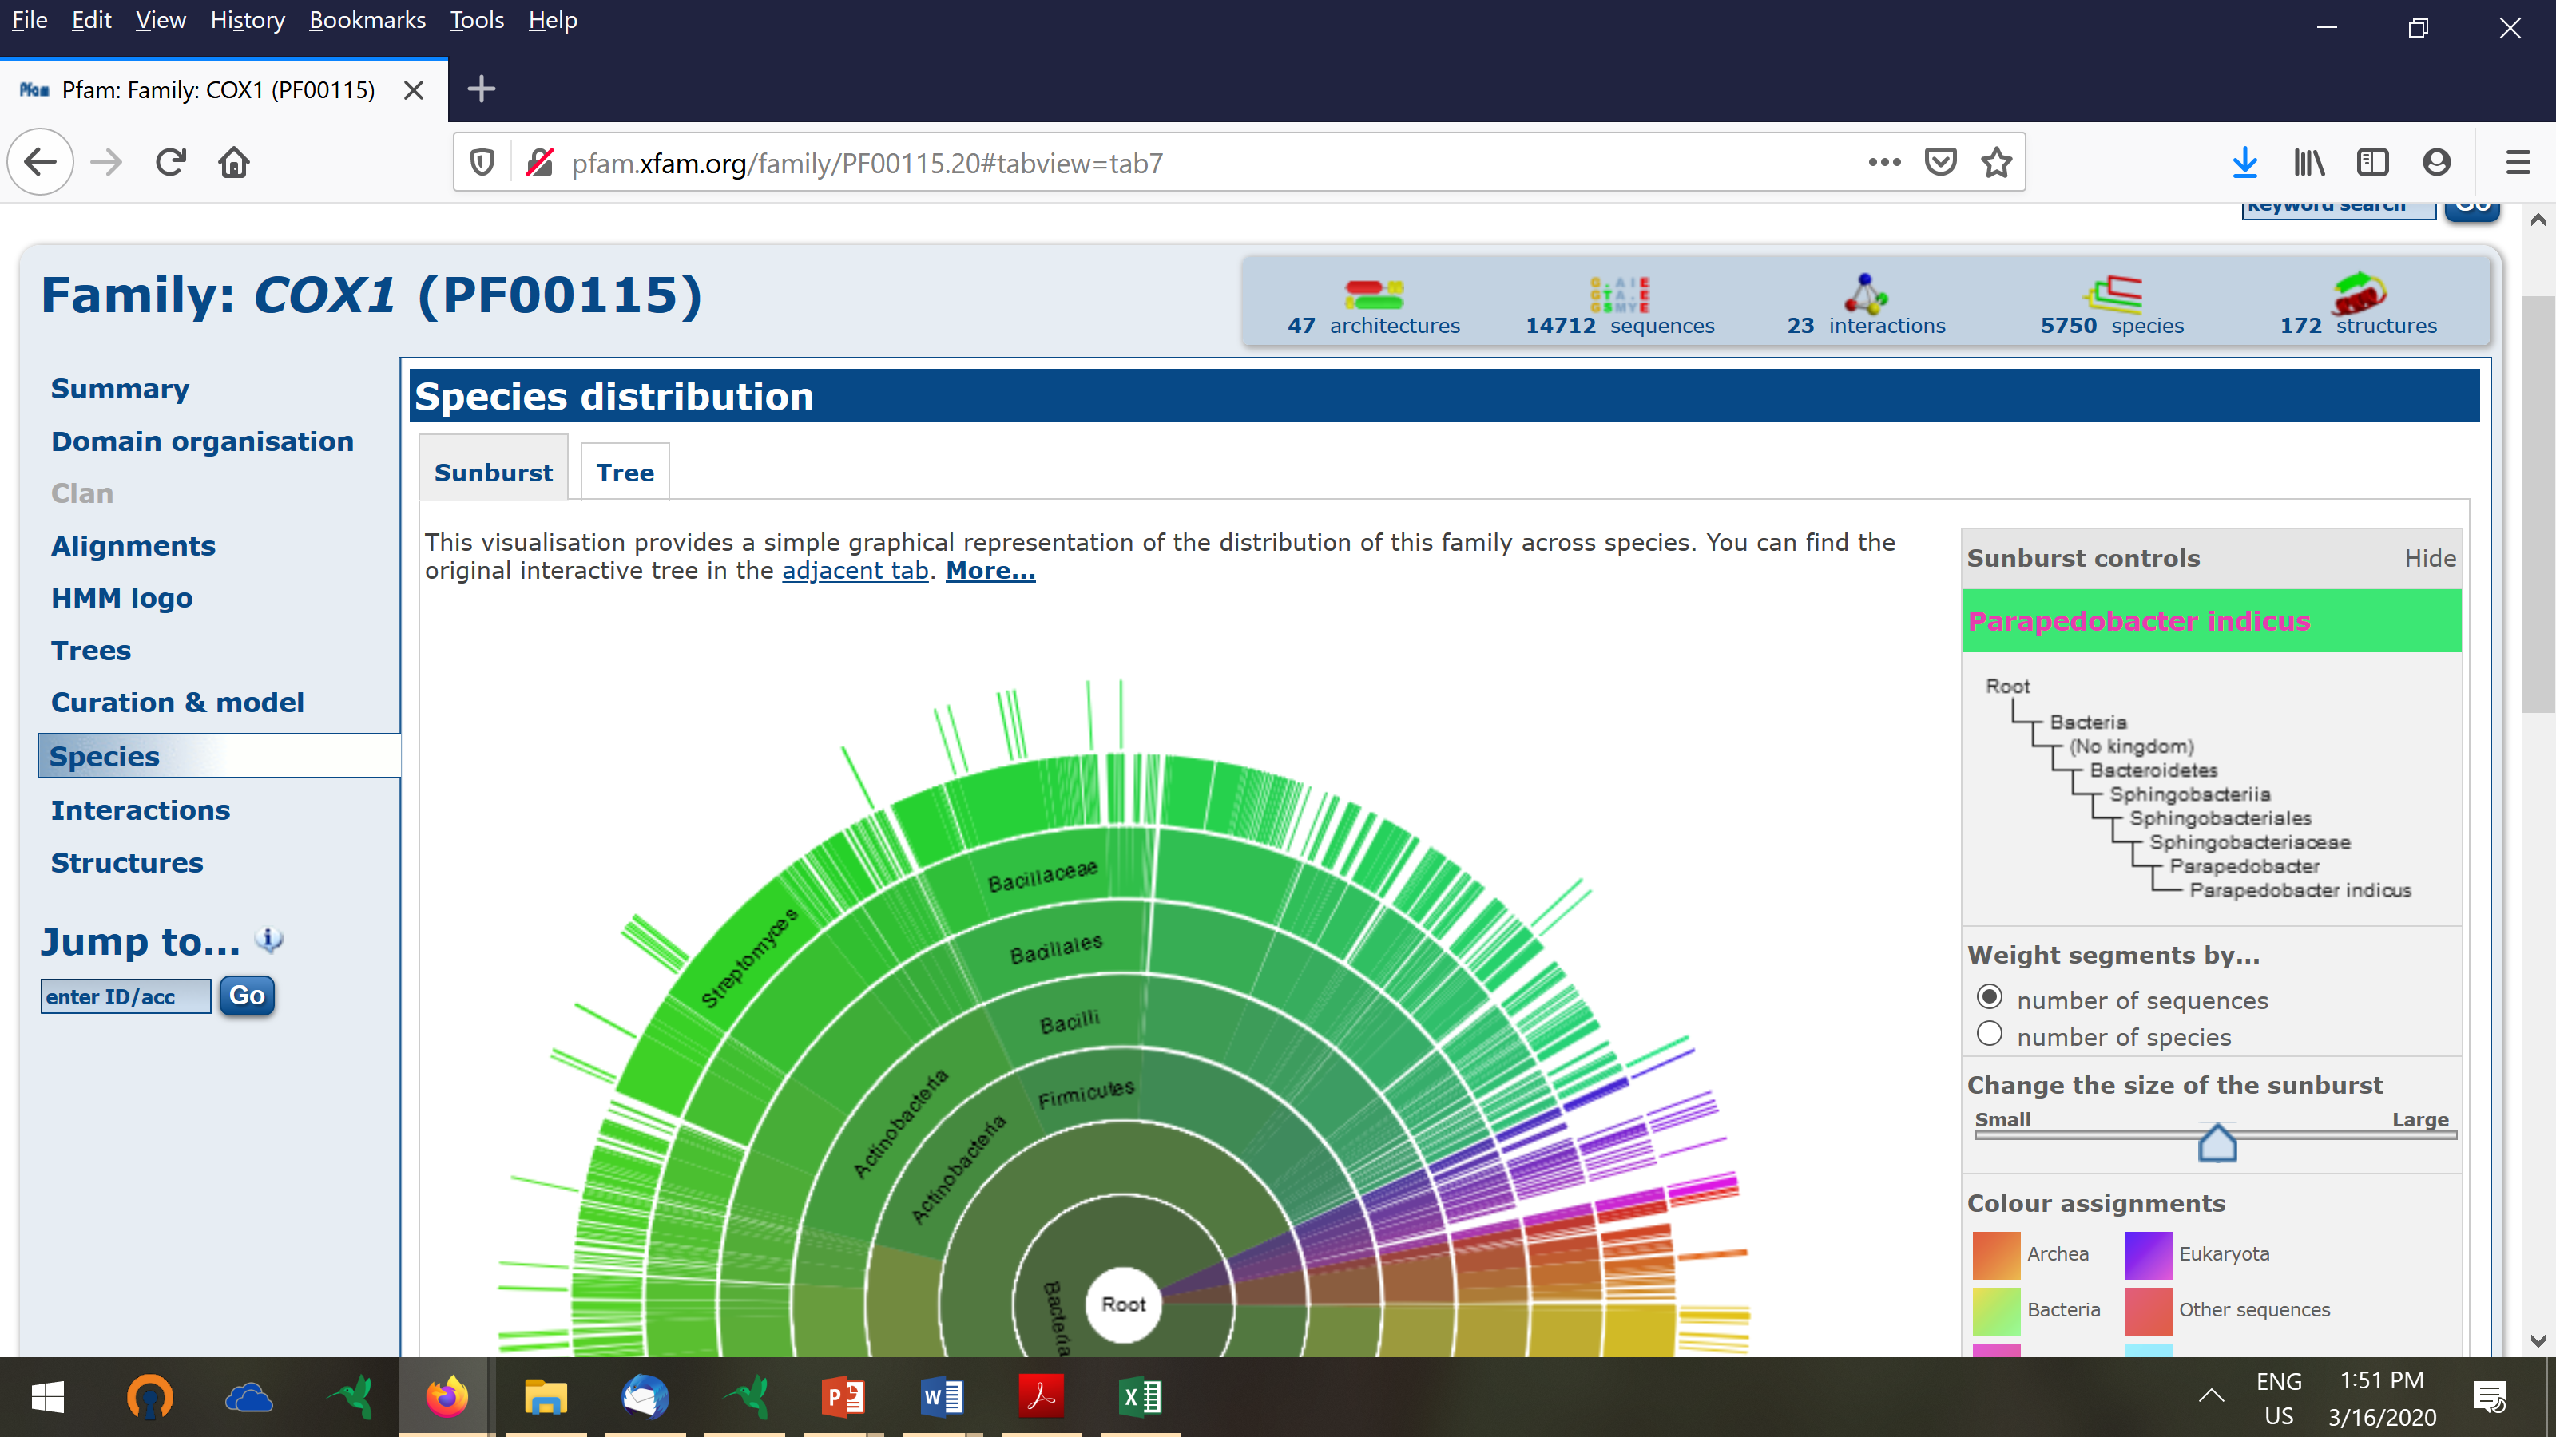

**View curated model**



Download the PFAM HMM model for the cox domain and interpret the results (refer to slide 20 and 22 presentatie_Motif_representation_Marchal_2020_part2.ppt):

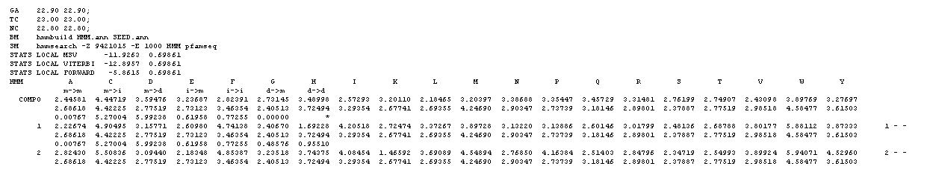

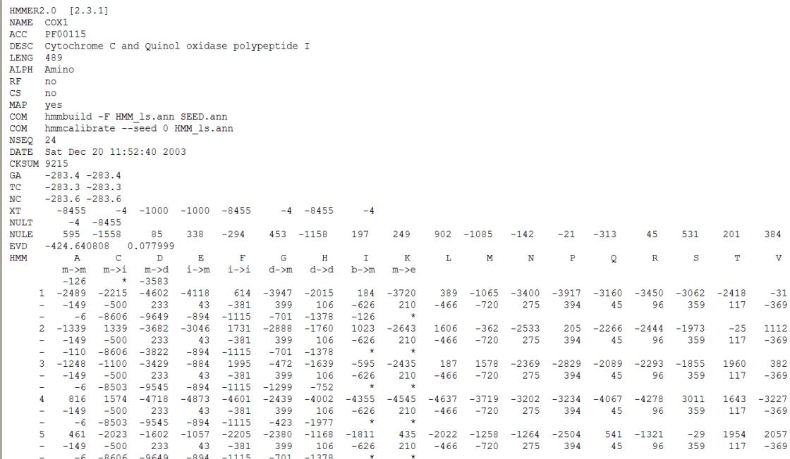

NULT: the transition probability distribution of the null model.

NULE: the symbol emission probability for the null model; consists of K integers (4 or 20).

A “null model” is used to calculate the HMMER log odds scores. The null model states the expected background occurrence frequencies of 20 amino acids or the 4 nucleotide bases. For protein models the 20 residue frequencies are by default set to the amino acid composition of SWIISPROT 34.

Match emission line: the first field is the node number (column in the alignment); The next K numbers are the match emission scores.

Insert emission line: The K numbers are the insert emission scores.

State transition line: 9 state transition scores. The order is given by the annotation line:

M->M, M->I, M->D, I->M, I->i, D->M, D->D



Why are there no emission probabilities for the deletion states?

## Homology search by InterPro



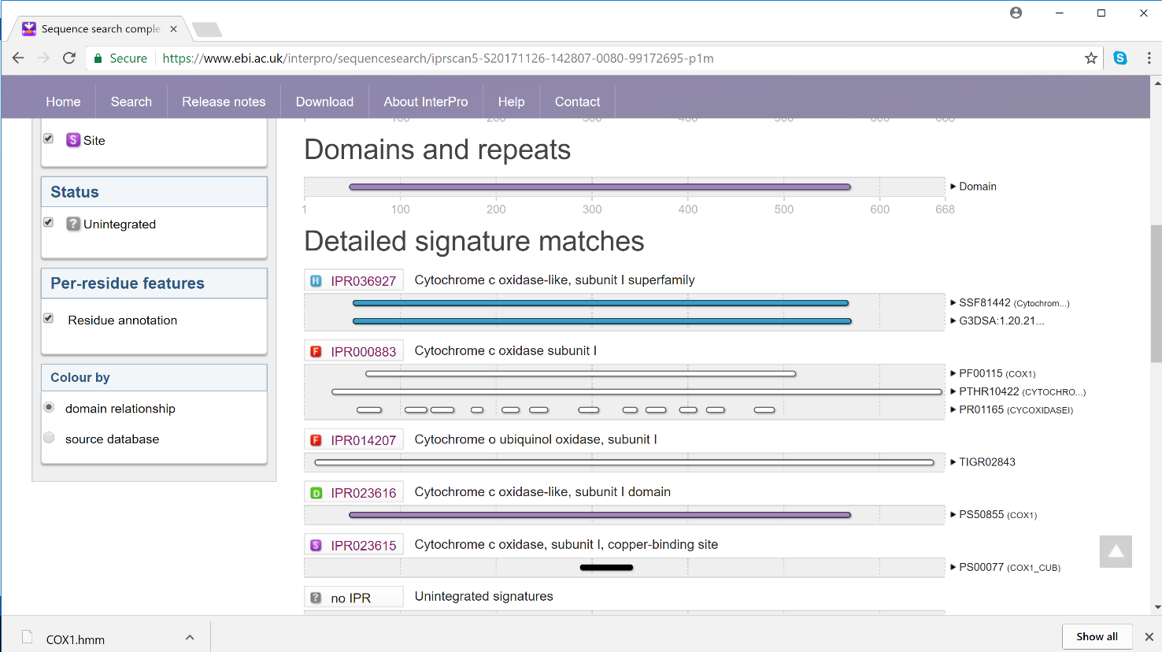

This tool performs a search on several well known protein motif databases. Find in the output the hits with PFAM and PROSITE. What is the advantage of using this tool over the individual tools?

## Extra exercise

Retrieve the protein sequence AAD42764.1 at NCBI.

Do motif search of this sequence using different programs. Look at statistical scores, if available, and the boundaries of the motifs/domains. What is your conclusion on the motifs/domains present in this protein?

Answer: The protein contains the xlink domain involved in cellular adhesion.